**Q1: Can you create a basic HTML search form with a text input and a submit button?**



<form action="search.php" method="get">

<label for="search-input">Search:</label>

<input type="text" id="search-input" name="search_query">

<button type="submit">Search</button>

</form>

**Q2: Generate a search form with filters including a keyword field, a category dropdown, and date range inputs using HTML and basic styling.**

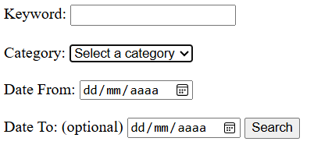

<form id="search-form">

<label for="keyword">Keyword:</label>

<input type="text" id="keyword" name="keyword"><br><br>

<label for="category">Category:</label>

<select id="category" name="category">

<option value="">Select a category</option>

<option value="computers">Computers</option>

<option value="electronics">Electronics</option>

<option value="home-appliances">Home Appliances</option>

</select><br><br>

<label for="date-from">Date From:</label>

<input type="date" id="date-from" name="date-from"><br><br>

<label for="date-to">Date To:</label> (optional)

<input type="date" id="date-to" name="date-to">

<button type="submit">Search</button>

</form>

```

CSS (styling the form and input fields):

```

#search-form {

border: 1px solid #ccc;

padding: 20px;

margin: 20px 0;

}

label {

display: block;

margin-bottom: 10px;

}

input[type="text"], input[type="date"] {

width: 100%;

padding: 10px;

border: 1px solid #ccc;

margin-bottom: 20px;

}

select {

width: 100%;

padding: 10px;

border: 1px solid #ccc;

margin-bottom: 20px;

}

button {

width: 100%;

padding: 10px;

background-color: #4CAF50;

color: white;

border: none;

cursor: pointer;

}

```

JavaScript (filtering the search results based on the input fields):

```

const form = document.getElementById('search-form');

const keywordInput = document.getElementById('keyword');

const categorySelect = document.getElementById('category');

const dateFromInput = document.getElementById('date-from');

const dateToInput = document.getElementById('date-to');

form.addEventListener('submit', (e) => {

e.preventDefault();

const keyword = keywordInput.value.trim();

const category = categorySelect.value;

const dateFrom = dateFromInput.value;

const dateTo = dateToInput.value;

// Perform search here based on the input fields

// ...

// Redirect to the search results page

window.location.href = 'searchResults.html';

});

**Q3: Build a styled HTML and JavaScript form that allows users to search using keywords, category filters, and a date range, and shows a filtered results table dynamically.**

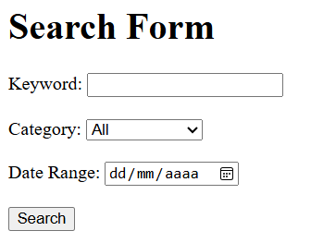

<!DOCTYPE html>

<html lang="en">

<head>

<meta charset="UTF-8">

<meta name="viewport" content="width=device-width, initial-scale=1.0">

<title>Search Form</title>

<link rel="stylesheet" href="styles.css">

</head>

<body>

<div class="container">

<h1>Search Form</h1>

<form id="searchForm">

<label for="keyword">Keyword:</label>

<input type="text" id="keyword" name="keyword"><br><br>

<label for="categoryFilter">Category:</label>

<select id="categoryFilter" name="categoryFilter">

<option value="all">All</option>

<option value="electronics">Electronics</option>

<option value="clothing">Clothing</option>

<option value="homeGoods">Home Goods</option>

</select><br><br>

<label for="dateRange">Date Range:</label>

<input type="date" id="dateRange" name="dateRange"><br><br>

<button type="submit">Search</button>

</form>

<table id="resultsTable"></table>

</div>

<script src="script.js"></script>

</body>

</html>

```

JavaScript Code:

```javascript

const form = document.getElementById('searchForm');

const keywordInput = document.getElementById('keyword');

const categoryFilterSelect = document.getElementById('categoryFilter');

const dateRangeInput = document.getElementById('dateRange');

const resultsTable = document.getElementById('resultsTable');

form.addEventListener('submit', (e) => {

e.preventDefault();

const keyword = keywordInput.value.toLowerCase();

const category = categoryFilterSelect.value;

const dateFrom = dateRangeInput.value;

// Make API call to search data based on keywords, category, and date range

fetch('/search?keyword=' + keyword + '&category=' + category + '&dateFrom=' + dateFrom)

.then(response => response.json())

.then((data) => {

// Display search results in table format

const results = data.results;

const tableBody = document.createElement('tbody');

for (const result of results) {

const tr = document.createElement('tr');

const tdKeyword = document.createElement('td');

const tdCategory = document.createElement('td');

const tdDate = document.createElement('td');

const tdPrice = document.createElement('td');

tdKeyword.innerHTML = result.keyword;

tdCategory.innerHTML = result.category;

tdDate.innerHTML = moment(result.date).format('LLL');

tdPrice.innerHTML = result.price;

tr.appendChild(tdKeyword);

tr.appendChild(tdCategory);

tr.appendChild(tdDate);

tr.appendChild(tdPrice);

tableBody.appendChild(tr);

}

resultsTable.appendChild(tableBody);

})

.catch((error) => {

console.log('Error:', error);

});

});